**How to Create a Video with PowerPoint**

**7 (seven) minutes**

1. Create a PowerPoint (PPT) presentation as usual, with animations and transitions. Customise a PPT template or create your own design for slides with a consistent and attractive appearance. After the slide design is produced, start adding content.
2. Record the narration or sound (audio) first, before embedding it in slides.
3. 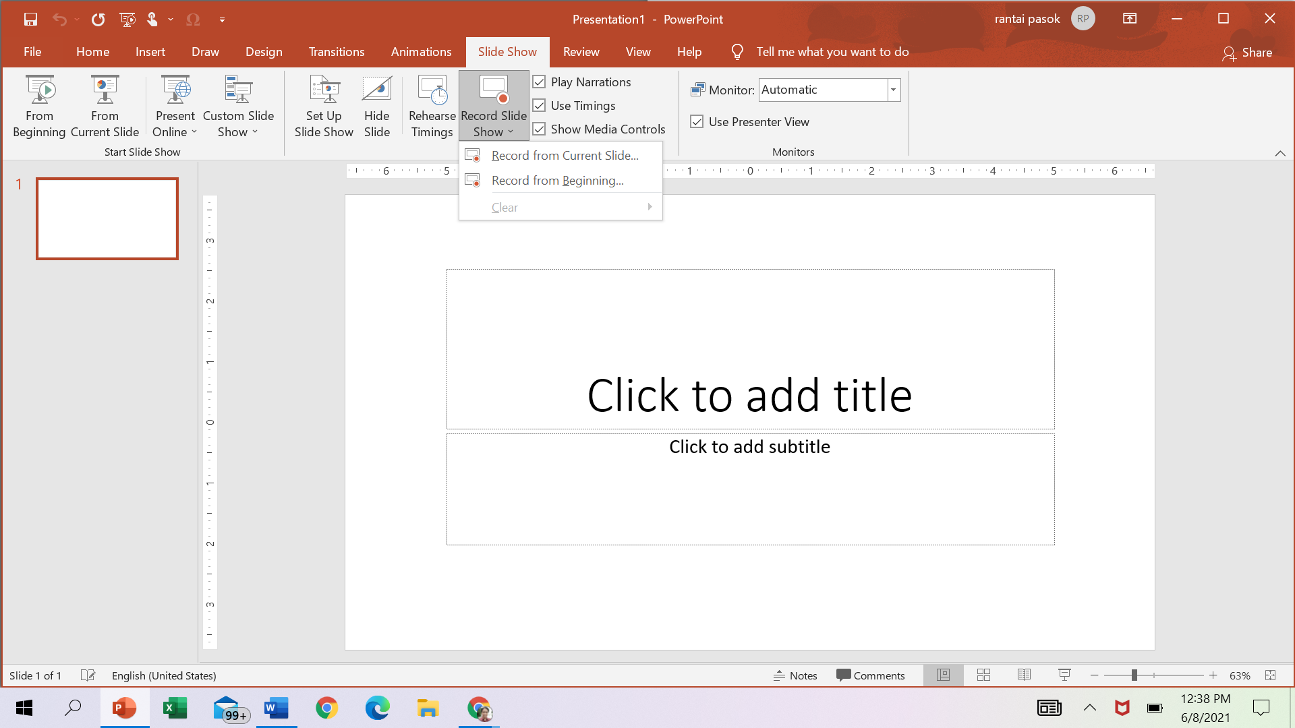Set the duration of the transition between slides; this can be up to a total of **7** (**seven) minutes.**

* A recording can be embedded in each slide by selecting Record from the Current Slide.
* You can choose the duration of each slide, sound when describing slides, cursor position, and even pointer options.

1. The process of creating PPT videos depends on the size of the presentation, the media embedded in slides, and the video quality you choose (when converting to MP4).

**Convert the PPT to MP4 video**

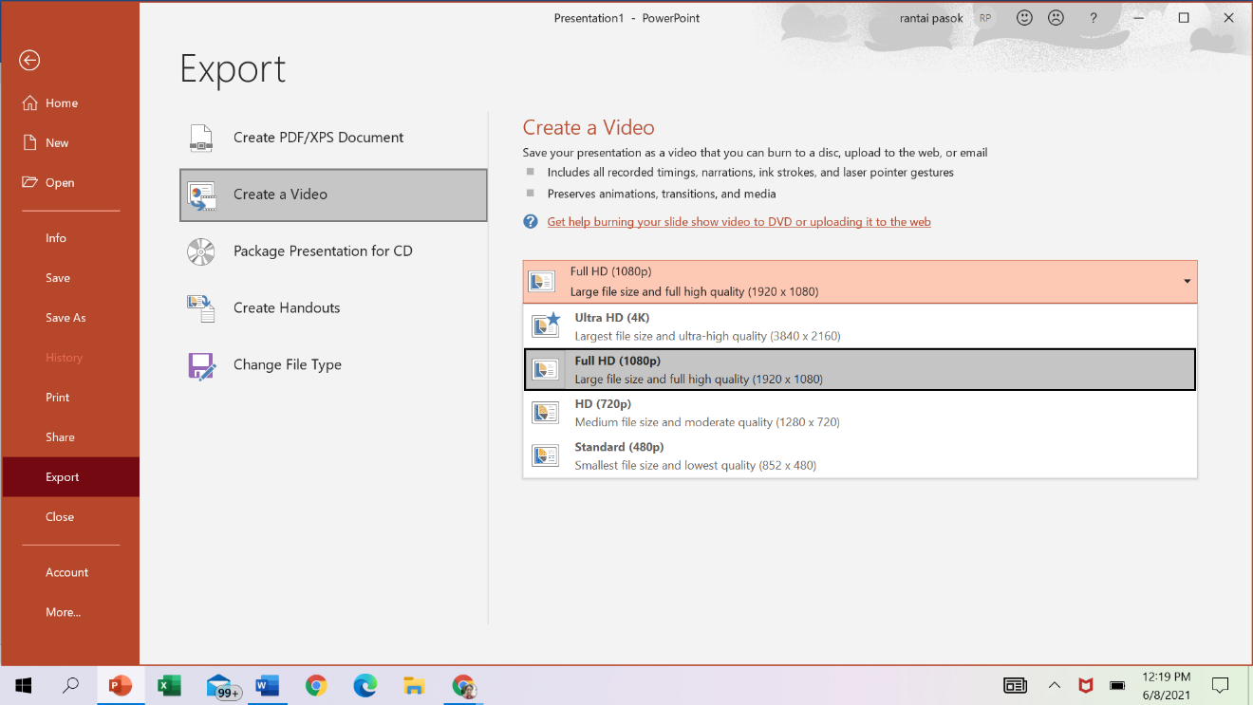

1

4

3

2

Start PPT and then create a presentation slide, or open the PPT file if you already have one, and then click File in the top menu.

1. and 2. Select the Export option and then Create a Video.

3. and 4 Specify file quality as 720p.

4. Click Create Video and specify the storage location, and wait for the process to finish.

**Storage in Google Drive for committee reading and uploading**

1. If you don't have a google drive account, create a google drive account

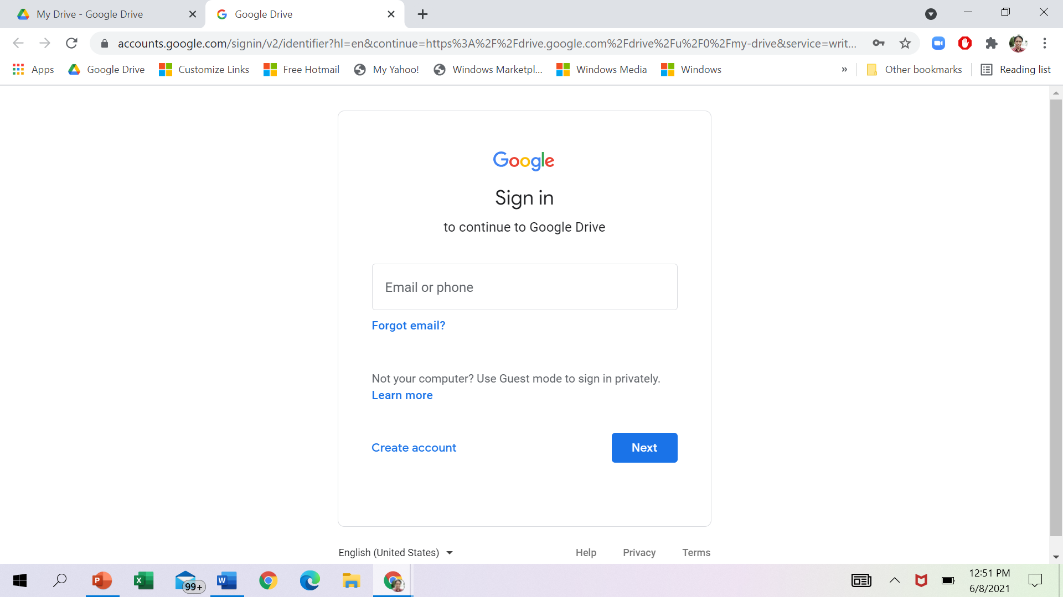

1

1. If you are already signed in to your Google Drive account, select My Drive and then Upload files.

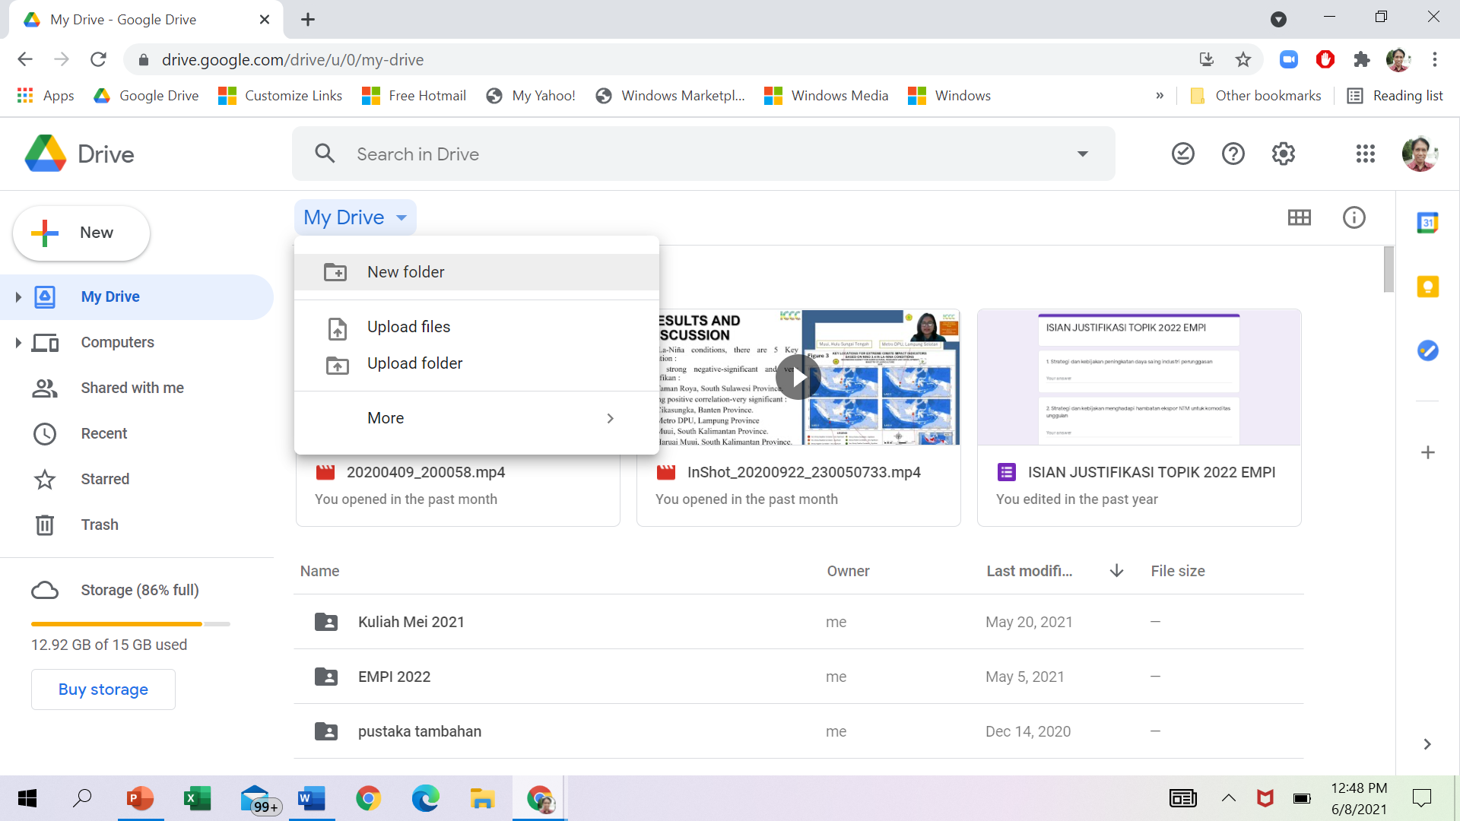

2

2a

1. If you are already signed in to your Google Drive account, select My Drive and then Upload files🡪 example (sample file that has been uploaded)

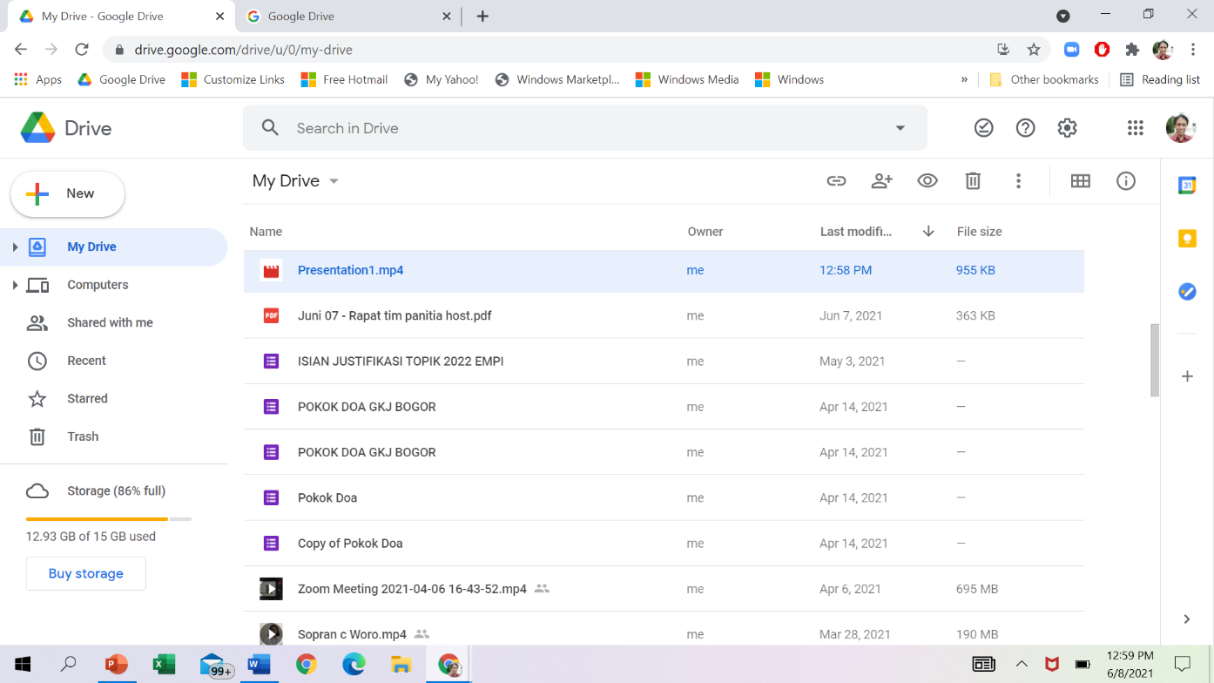

3

1. For the file to be read by the committee, right click on it and select Get link.

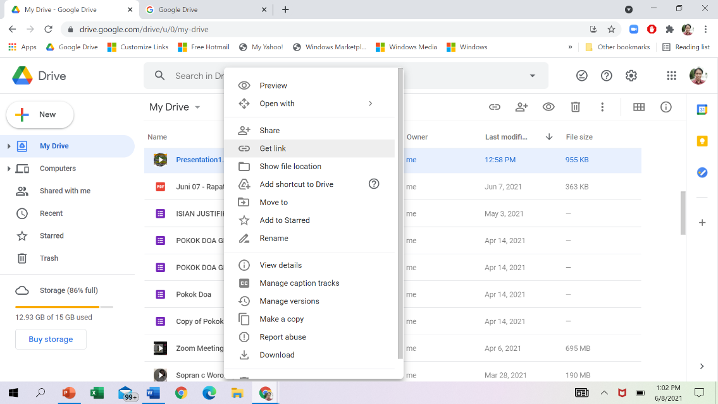

4

1. Before sending the link to the committee, set sharing permissions: (a) Anyone with the link, or (b) Editor. Then click Done.

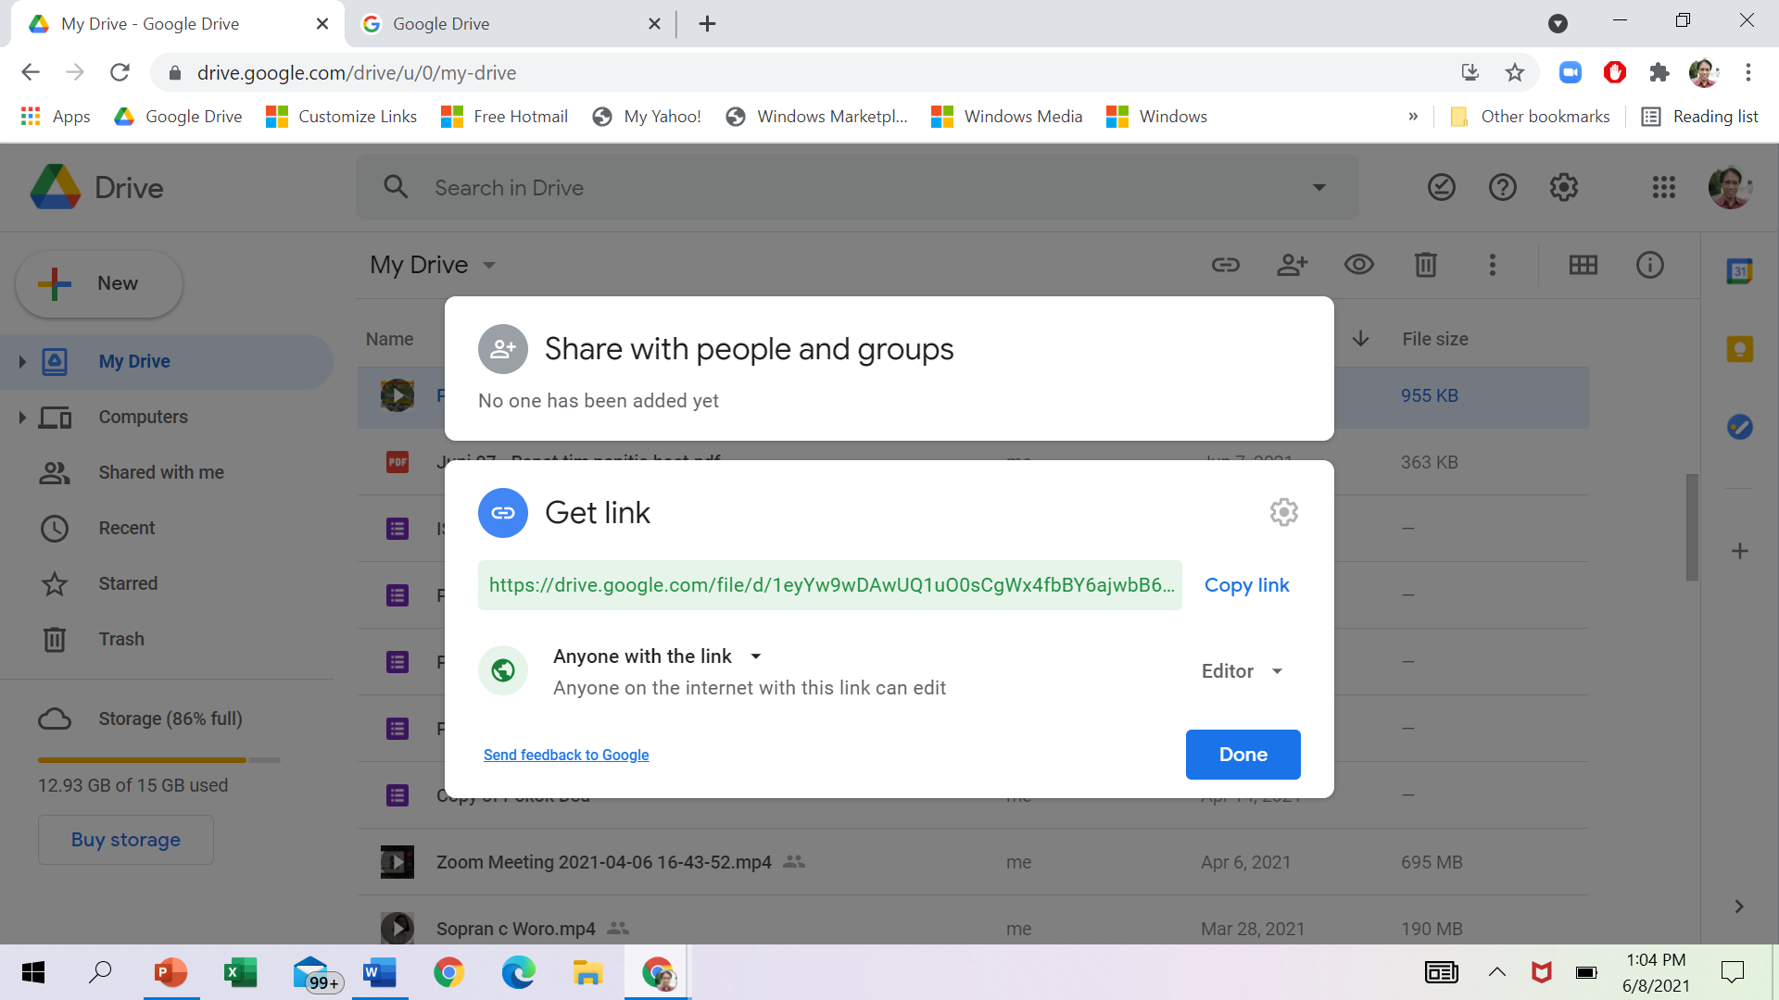

b

a

c

5. Send the link to the committee: **right-click**, select **Get link**, select **Copy link**, and then **paste** the link to **https://bit.ly/icanard2-presentation**.

Good luck!